AWS LAB EXERCISE

Deploy Website using EC2 + Domain + Route 53

🎯 Objective
- Launch EC2 instance
- Install and configure Apache (httpd)
- Access website via Public IP
- Purchase domain from GoDaddy / Hostinger
- Configure DNS (A & CNAME)
- Use Amazon Route 53 Hosted Zone
- Map domain → EC2 → Access website

📌 Naming Convention (IMPORTANT)
Resource | Name
EC2 Instance | studentname-ec2
Security Group | studentname-sg
Key Pair | studentname-key
Hosted Zone | studentname.com

🧪 PART 1: Create EC2 + Web Server
Step 1: Launch EC2 Instance
- Go to AWS Console → Amazon EC2
- Click Launch Instance
- Configure:
  - Name: studentname-ec2
  - AMI: Amazon Linux 2
  - Instance type: t2.micro (Free tier)
  - Key pair: studentname-key
  - Security Group: studentname-sg
Step 2: Configure Security Group
Allow:
- SSH → Port 22 → Your IP
- HTTP → Port 80 → Anywhere (0.0.0.0/0)
- 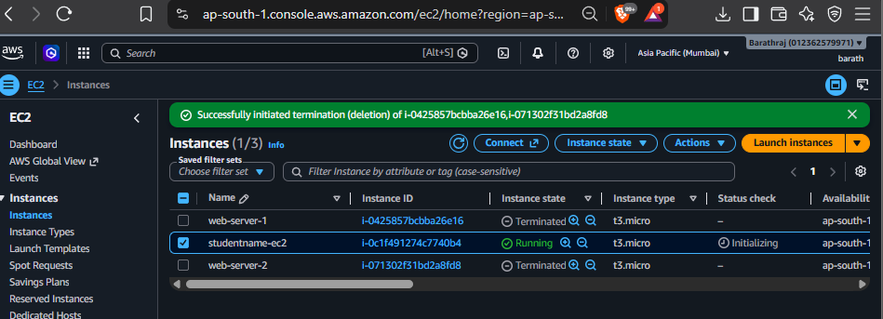

Step 3: Install Apache (httpd)
Connect via SSH:
ssh -i studentname-key.pem ec2-user@<PUBLIC-IP>
Run:
sudo yum update -y
sudo yum install httpd -y
sudo systemctl start httpd
sudo systemctl enable httpd
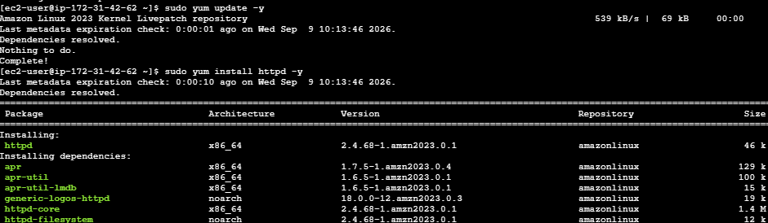
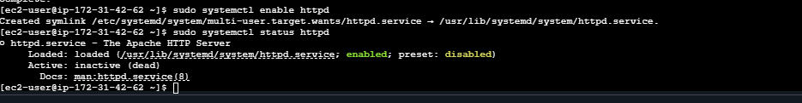

Step 4: Create Web Page
echo "<h1>Welcome to Student Lab - AWS Web Server</h1>" | sudo tee /var/www/html/index.html

Step 5: Test via Public IP
Open browser:
http://<PUBLIC-IP>
✅ You should see your webpage
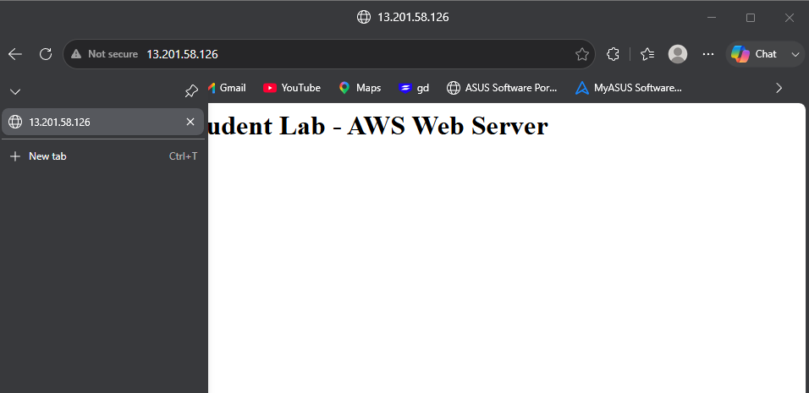

🌍 PART 2: Domain Purchase
Buy a domain from:
- GoDaddy
- Hostinger
Example:
studentname.com
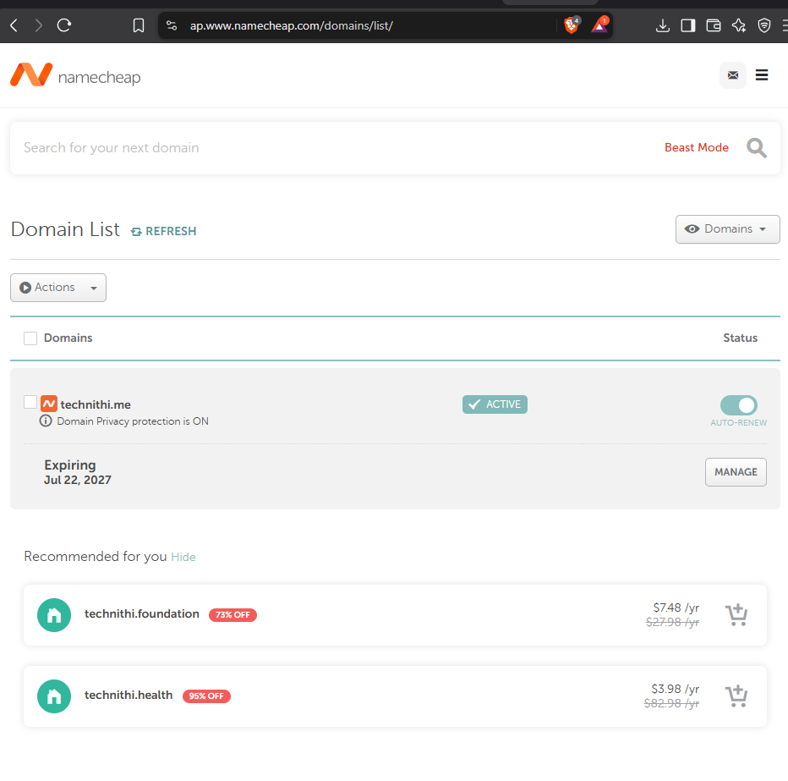
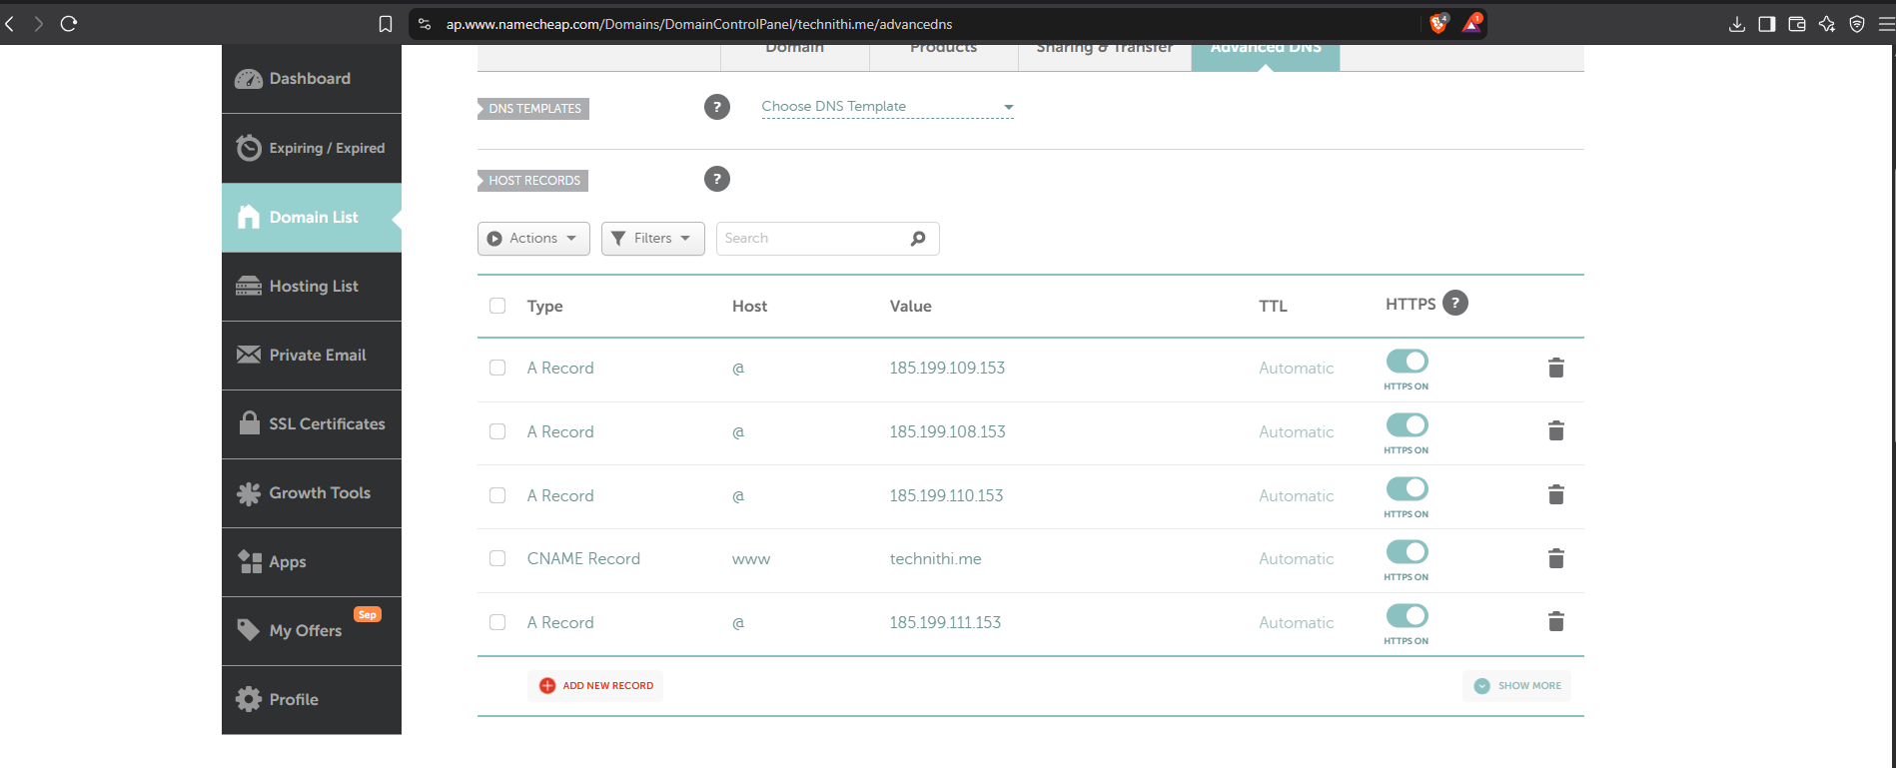

🔗 PART 3: Direct Domain Mapping (Without Route 53)
Step 6: Add A Record (in GoDaddy/Hostinger)
- Type: A
- Name: @
- Value: EC2 Public IP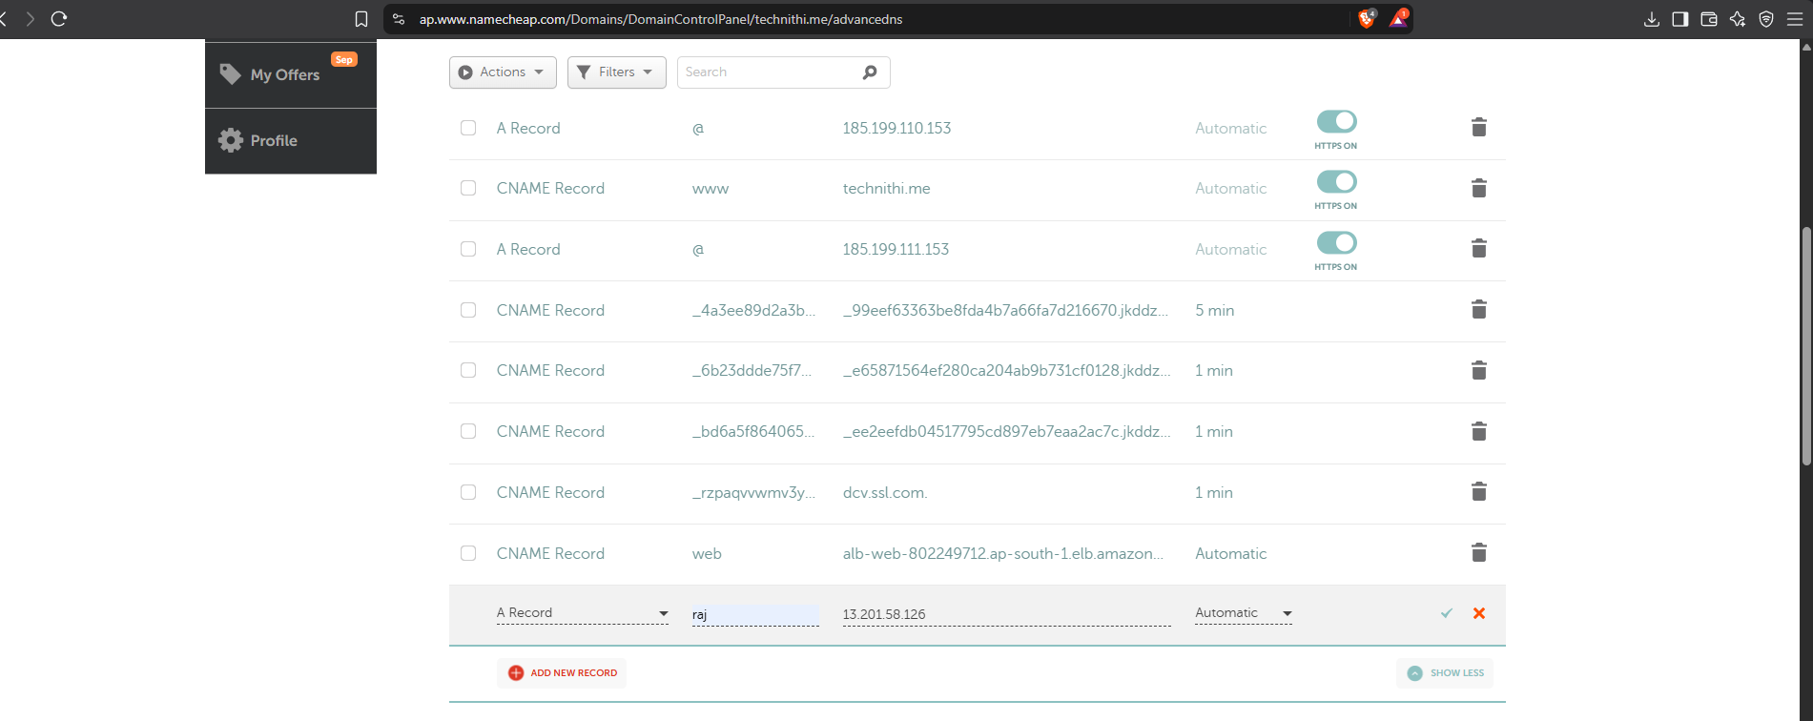
Step 7: Add CNAME Record
- Name: www
- Value: studentname.com

Step 8: Validate
Open:
http://studentname.com
http://www.studentname.com
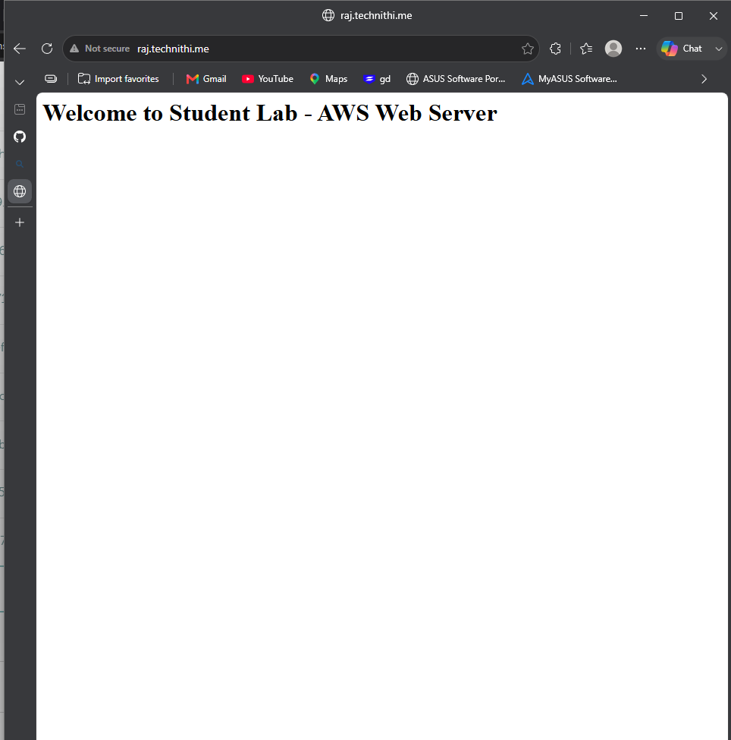

☁️ PART 4: Route 53 Hosted Zone Setup
Step 9: Create Hosted Zone
Go to → Amazon Route 53
- Click Hosted Zones
- Create Hosted Zone:
  - Domain: studentname.com
  - Type: Public
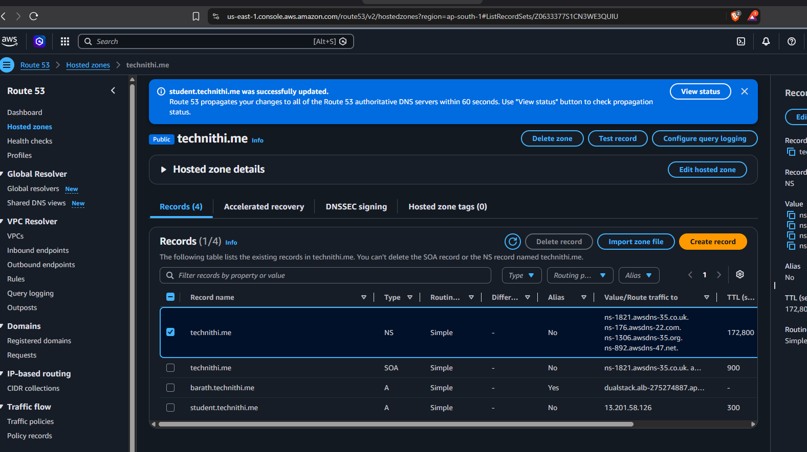

Step 10: Copy Name Servers
You will see 4 NS records like:
ns-123.awsdns-xx.com
ns-456.awsdns-xx.net
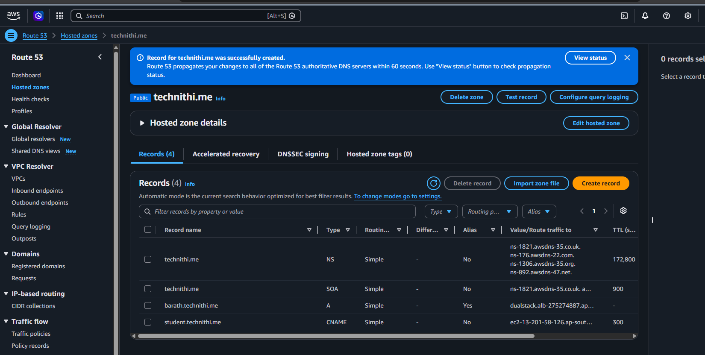

Step 11: Update Name Servers in Domain Provider
In:
- GoDaddy or Hostinger
Replace default nameservers with AWS nameservers.
⏳ Wait 5–15 minutes (can take up to 24 hours)
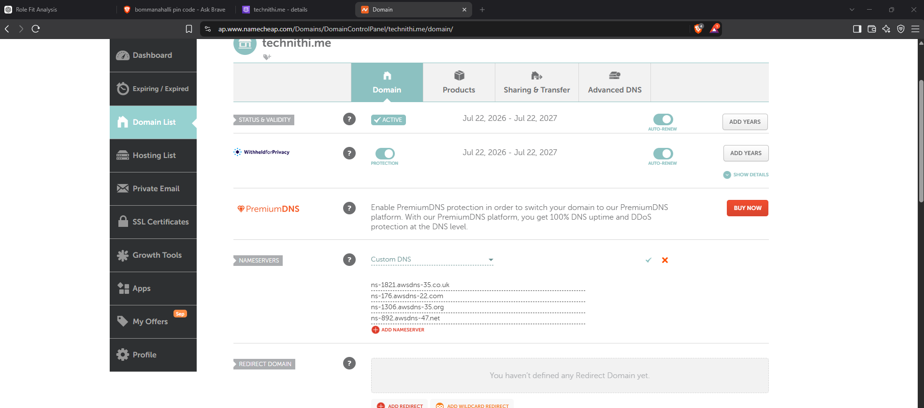

🌐 PART 5: Create Records in Route 53
Step 12: Create A Record
- Type: A
- Name: (leave blank or @)
- Value: EC2 Public IP
- 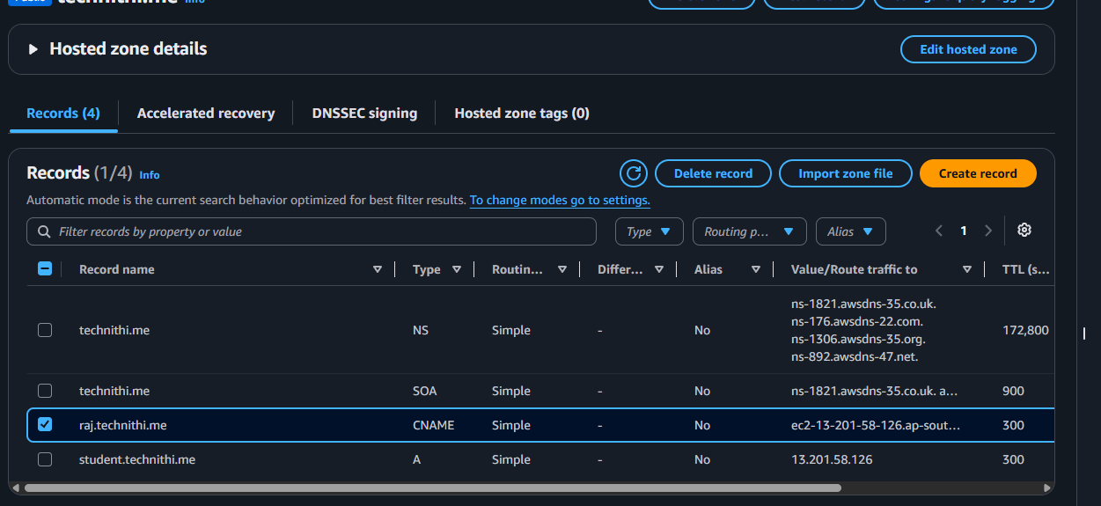

Step 13: Create CNAME Record
- Type: CNAME
- Name: www
- Value: studentname.com

✅ PART 6: Validation
Test in browser:
http://studentname.com
http://www.studentname.com
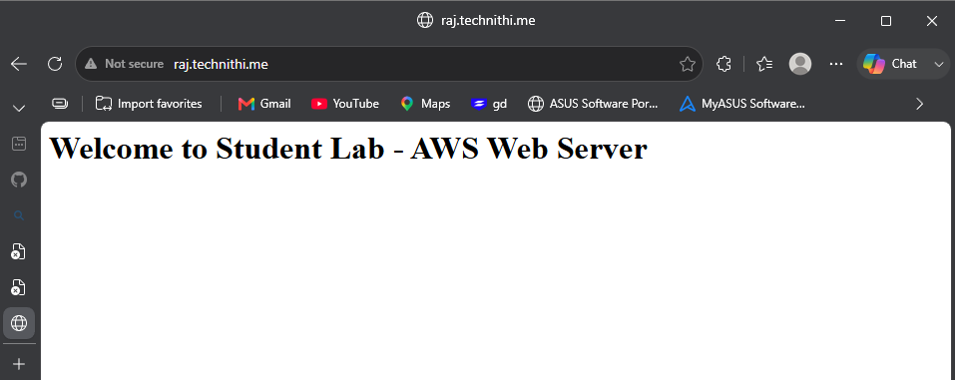

🔍 Verification Commands (Optional)
nslookup studentname.com
dig studentname.com

🎯 Expected Outcome
- Website accessible via:
  - Public IP ✅
  - Domain name ✅
  - www subdomain ✅

🧠 Bonus Tasks (For Students)
- Add HTTPS using SSL (Let's Encrypt)
- Create a second EC2 and use Load Balancer
- Enable monitoring using CloudWatch

📌 Architecture Flow
User Browser
↓
Domain (GoDaddy/Hostinger)
↓
Route 53 (DNS)
↓
EC2 (Apache Web Server)
↓
Website Response

